SAMPLE PAPER – 2008-09
INTRODUCTORY COMPUTER SCIENCE (Theory)

CLASS – XII

Time allowed : 3 hours Maximum marks : 70
Note :
- All the questions are compulsory .
- Programming Language : C++ .

  - a) What is the difference between #define & const ? Explain through example. 2
b) Name the header files that shall be required for successful compilation of the following C++ program : 1
main( )
{ char str[20];
cout<<fabs(-34.776);
cout<<”\n Enter a string : ”;
cin.getline(str,20);
return 0; }
c) Rewrite the following program after removing all the syntactical errors underlining each correction. (if any) 2
#include<iostream.h>
#include<stdio.h>
struct NUM
{ int x;
float y;
}*p;
void main( )
{
NUM A=(23,45.67);
p=A;
cout<<”\n Integer = “<<*p->x;
cout<<”\n Real = “<<*A.y;
}
d) Find the output of the following program segment ( Assuming that all required header files are included in the program ) : 3
void FUNC(int *a,int n)
{ int i,j,temp,sm,pos;
for(i=0;i<n/2;i++)
for(j=0;j<(n/2)-1;j++)
if(*(a+j)>*(a+j+1))
{ temp=*(a+j);
*(a+j)=*(a+j+1);
*(a+j+1)=temp; }
for(i=n-1;i>=n/2;i--)
{ sm=*(a+i);
pos=i;
for(j=i-1;j>=n/2;j--)
if(*(a+j)<sm)
{ pos=j;
sm=*(a+j); }
temp=*(a+i);
*(a+i)=*(a+pos);
*(a+pos)=temp; } }
void main( )
{
int w[ ]={-4,6,1,-8,19,5},i;
FUNC(w,6);
for(i=0;i<6;i++)
cout<<w[i]<<' ';}
e) Give the output of the following program ( Assuming that all required header files are included in the program ) : 2
class state
{
private:
char *stname;
int size;
public:
state( )
{ size=0;
stname=new char[size+1];}
state(char *s)
{ size=strlen(s);
stname=new char[size+1];
strcpy(stname,s); }
void disp( )
{ cout<<stname<<endl; }
void repl(state &a, state &b)
{size=a.size+b.size;
delete stname;
stname=new char[size+1];
strcpy(stname,a.stname);
strcat(stname,b.stname); } };
void main( )
{ char *st1="Punjab";
clrscr( );
state ob1(st1),ob2("Uttaranchal"),ob3("Madhyapradesh"),s1,s2;
s1.repl(ob1,ob2);
s2.repl(s1,ob3);
s1.disp( );
s2.disp( ); getch( ); }
f) Observe the following program carefully & choose the correct possible output from the options (i) to (iv) justifying your answer. 2
#include<iostream.h>
#include<conio.h>
#include<stdlib.h>
void main( )
{
clrscr( );
randomize( );
int RN;
RN=random(4)+5;
for(int i=1;i<=RN;i++)
cout<<i<<' ';
getch(); }
i) 0 1 2 ii)1 2 3 4 5 6 7 8 iii) 4 5 6 7 8 9 iv) 5 6 7 8 9 10 11 12
2. a) Differenciate between default & parameterized constructor with suitable example. 2
b) Answer the questions i) and ii) after going through the following class : 2
#include<iostream.h>
#include<string.h>
#include<stdio.h>
class wholesale
{ char categ[20],item[30];
float pr;
int qty;
wholesale( ) // Function 1
{ strcpy(categ ,”Food”);
strcpy(item,”Biscuits”);
pr=150.00;
qty=10 }
public :
void SHOW( ) //Function 2
{
cout<<categ<<”#”<<item<<”:”<<pr<<”@”<<qty<<endl;
}
};
void main( )
{ wholesale ob; //Statement 1
ob.SHOW( ); //Statement 2
}
i) Will statement 1 initialize all the data members for object ob with the values given in function 1?(Y/N). Justify your answer suggesting the corrections to be made in the above code.
ii) What shall be the possible output when the program gets executed? (Assuming, if required- the suggested correction(s) are made in the program.
c) Defne a class WEAR in C++ with following description : 4
Private members :
code string
Type string
Size integer
material string
Price real number
A function calprice( ) that calculates and assign the value of price as follows :
For the value of material as “WOOLEN”
Type Price(Rs.)
------- -------------
Coat 2400
Sweater 1600
For material other than “WOOLEN” the above mentioned price gets reduced by 30%.
Public members :
A constructor to get initial values for code, Type & material as “EMPTY” & size and price with 0.
A function INWEAR( ) to input the values for all the data members except price which will be initialized by function calprice( ).
Function DISPWEAR( ) that shows all the contents of data members

d) Answer the questions (i) to (iv) based on the following : 4
class COMP
{ private :
char Manufacturer [30];
char addr[15];
public:
toys( );
void RCOMP( );
void DCOMP( );
};
class TOY: public COMP
{ private:
char bcode[10];
public:
double cost_of_toy;
void RTOY ( );
void DTOY( );
};
class BUYER: public TOY
{ private:
char nm[30];
char delivery date[10];
char *baddr;
public:
void RBUYER( );
void DBUYER( );
};
void main ( )
{ BUYER MyToy; }

- Mention the member names that are accessible by MyToy declared in main( ) function.
- Name the data members which can be accessed by the functions of BUYER class.
- Name the members that can be accessed by function RTOY( ).
- How many bytes will be occupied by the objects of class BUYER?

3. a) Define a function that would accept a one dimensional integer array and its size. The function should reverse the contents of the array without using another array. (main( ) function is not required) 4
b) A two dimensional array A[15][25] having integers (long int), is stored in the memory along the column, find out the memory location for the element A[8][12], if an element A[10][6] is stored at the memory location 2800. 4
c) Evaluate the following postfix notation of expression : 2
5, 8, 7, +, /, 7, * , 13, -
d) ) Write a user defined function in C++ which accepts a squared integer matrix with odd dimensions (3*3, 5*5 …) & display the sum of the middle row & middle column elements. For ex. :
2 5 7 2
3 7 2
5 6 9
The output should be :
Sum of middle row = 12
Sum of middle column = 18
e) Consider the following program for linked QUEUE : 4
struct NODE
{ int x;
float y;
NODE *next; };

class QUEUE
{ NODE *R,*F;;
public :
QUEUE( )
{ R=NULL;
F=NULL;
}
void INSERT( );
void DELETE( );
void Show( );
~QUEUE( ); };
Define INSERT( ) & DELETE( ) functions outside the class.

4. a) Observe the following program carefully and fill in the blanks using seekg( ) and tellg( ) functions : 1
#include<fstream.h>
class school
{ private :
char scode[10],sname[30];
float nofstu;
public:
void INPUT( );
void OUTPUT( );
int COUNTREC( ); };
int school::COUNTREC( )
{ fstream fin(“scool.dat”,ios::in|ios::binary);
_________________ //statement 1
int B=_______________ //statement 2
int C=B/sizeof(school);
fin.close( );
return C; }
b) Write a function in c++ to count the number of words starting with capital alphabet present in a text file DATA.TXT. 2
c) Write a function in c++ to add new objects at the bottom of binary file “FAN.DAT”, assuming the binary file is containing the objects of following class : 3
class FAN
{ private:
int srno;
char name[25];
float pr;
public:
void Enter( ){ cin>>srno; gets(name); cin>>pr; }
void Display( ){ cout<<srno<<name<<pr<<endl;} };

5. a) What do you mean by degree & cardinality of a relation? Explain with example. 2
b) Consider the tables FLIGHTS & FARES. Write SQL commands for the statements (i) to (iv) and give the outputs for SQL queries (v) & (vi) .

Table : FLIGHTS
FNO | SOURCE | DEST | NO_OF_FL | NO_OF_STOP
IC301 | MUMBAI | BANGALORE | 3 | 2
IC799 | BANGALORE | KOLKATA | 8 | 3
MC101 | DELHI | VARANASI | 6 | 0
IC302 | MUMBAI | KOCHI | 1 | 4
AM812 | LUCKNOW | DELHI | 4 | 0
MU499 | DELHI | CHENNAI | 3 | 3

Table : FARES
FNO | AIRLINES | FARE | TAX
IC301 | Indian Airlines | 9425 | 5%
IC799 | Spice Jet | 8846 | 10%
MC101 | Deccan Airlines | 4210 | 7%
IC302 | Jet Airways | 13894 | 5%
AM812 | Indian Airlines | 4500 | 6%
MU499 | Sahara | 12000 | 4%
i) Display flight number & number of flights from Mumbai from the table flights. 1
ii) Arrange the contents of the table flights in the descending order of destination. 1
iii) Increase the tax by 2% for the flights starting from Delhi. 1
iv) Display the flight number and fare to be paid for the flights from Mumbai to Kochi using the tables, Flights & Fares, where the fare to be paid =fare+fare*tax/100. 1
v) SELECT COUNT(DISTINCT SOURCE) FROM FLIGHTS; 1
vi) SELECT FNO, NO_OF_FL, AIRLINES FROM FLIGHTS,FARES WHERE SOURCE=’DELHI’ AND FLIGHTS.FNO=FARES.FNO; 1

6. a) State and verify De Morgan’s law. 2
b) If F(A,B,C,D) = ∑ (0,1,2,4,5,7,8,10) , obtain the simplified form using K-Map. 3
c) Convert the following Boolean expression into its equivalent Canonical Sum of Products form (SOP) : 2
(X+Y+Z) (X+Y+Z’) (X’+Y+Z) (X’+Y’+Z’)
d) Write the equivalent Boolean Expression F for the following circuit diagram : 1
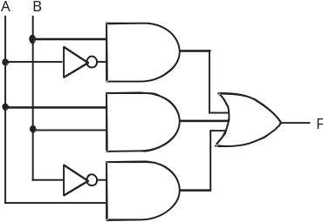

7. a) What is a switch? How is it different from hub? 1
b) What is the difference between optical fibre & coaxial transmission media. 1
c) Define cookies & firewall. 1
d) Expand WLL & XML 1
e) “Kanganalay Cosmetics” is planning to start their offices in four major cities in Uttar Pradesh to provide cosmetic product support in its retail fields. The company has planned to set up their offices in Lucknow at three different locations and have named them as “Head office”, “Sales office”, & “Prod office”. The company’s regional offices are located at Varanasi, Kanpur & Saharanpur. A rough layout of the same is as follows :
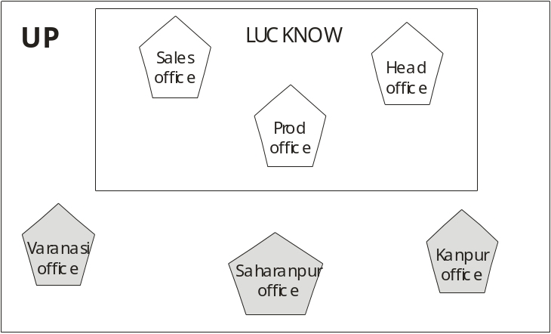
Approximate distances between these offices as per network survey team is as follows :

Place from | Place to | Distance
Head office | Sales office | 15 KM
Head office | Prod office | 8 KM
Head office | Varanasi Office | 295 KM
Head office | Kanpur Office | 195 KM
Head office | Saharanpur office | 408 KM
Number of computers :

Head office | 156
Sales office | 25
Prod office | 56
Varanasi Office | 85
Kanpur Office | 107
Saharanpur office | 105
- Suggest the placement of the repeater with justification. 1
- Name the branch where the server should be installed. Justify your answer. 1
- Suggest the device to be procured by the company for connecting all the computers within each of its offices out of the following devices : 1
- Modem
- Telephone
- Switch/Hub
- The company is planning to link its head office situated in Lucknow with the office at Saharanpur. Suggest an economic way to connect it; the company is ready to compromise on the speed of connectivity. Justify your answer. 1

